Business Proposal

Billy Li, Zixiong Feng, Ichiro Tai, Deepak Katariya (Group 9)

Below are our predictions on the trends of stock prices for the 4 given companies:

3M

Bayer

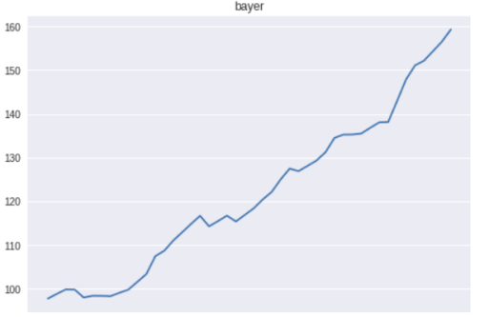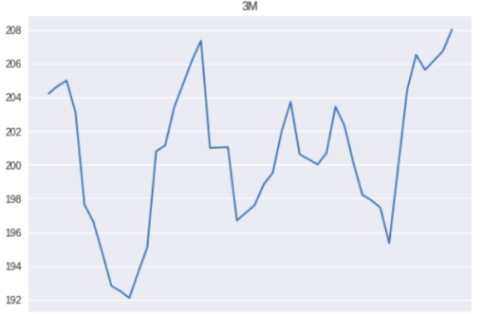

Synchrony Financial

Honeywell

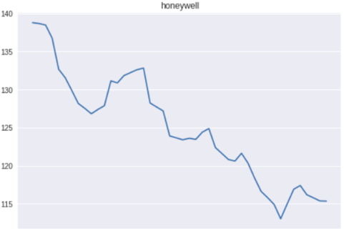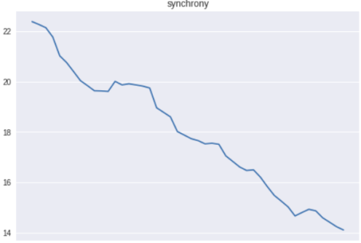

According to the predictions, in terms of stock growth rate there is no obvious contender for Bayer with a ~60% increase in stock prices from January 1st to February 15th. While our prediction may not be entirely accurate since it is based on a polynomial regression model which puts much emphasis on recent trends, we believe events which would cause a significant change in the growth rate of a stock are rather unpredictable, and the best way to deal with these unpredictable events is to not try to predict them at all.

Therefore, with Bayer showing the strongest trend in a significant period of time pre-2019, it is most reasonable to make the claim that Bayer is the best company to invest into for the first 6 weeks of 2019.